LAB – 10 IO FILES

1. Write a function in python to read the content from a text file "ABC.txt" line by line and display the same on screen.

def read_file():

    try:

        with open("ABC.txt", "r") as file:

            for line in file:

                print(line.strip())

    except FileNotFoundError:

        print("File 'ABC.txt' not found!")

read_file()

OUTPUT

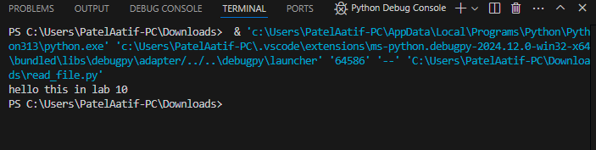

2. Write a function in Python to count and display the total number of words in a text file “ABC.txt”

def count_words():

    try:

        with open("ABC.txt", "r") as file:

            content = file.read()

            words = content.split()

            print(f"Total number of words: {len(words)}")

    except FileNotFoundError:

        print("File 'ABC.txt' not found!")

# Call the function

count_words()

OUTPUT

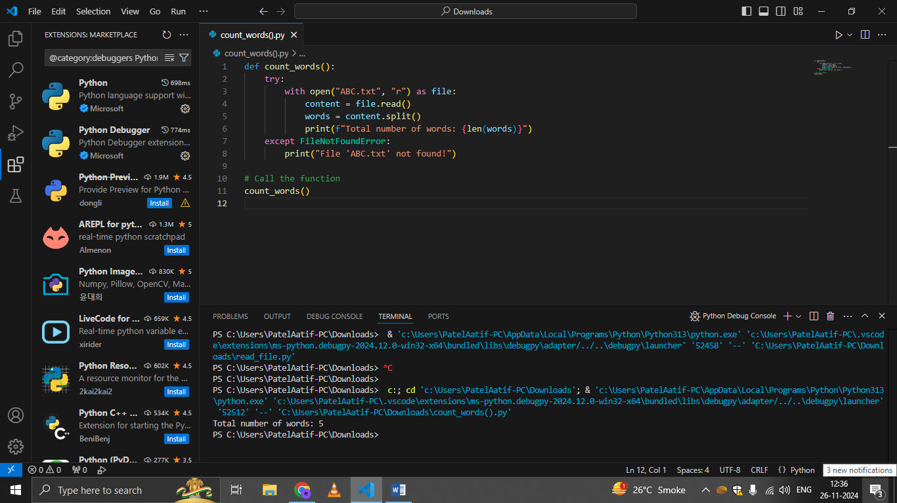

3. Write a function in Python to count uppercase character in a text file “ABC.txt”

def count_uppercase():

    try:

        with open("ABC.txt", "r") as file:

            content = file.read()

            uppercase_count = sum(1 for char in content if char.isupper())

            print(f"Total number of uppercase characters: {uppercase_count}")

    except FileNotFoundError:

        print("File 'ABC.txt' not found!")

# Call the function

count_uppercase()

OUTPUT

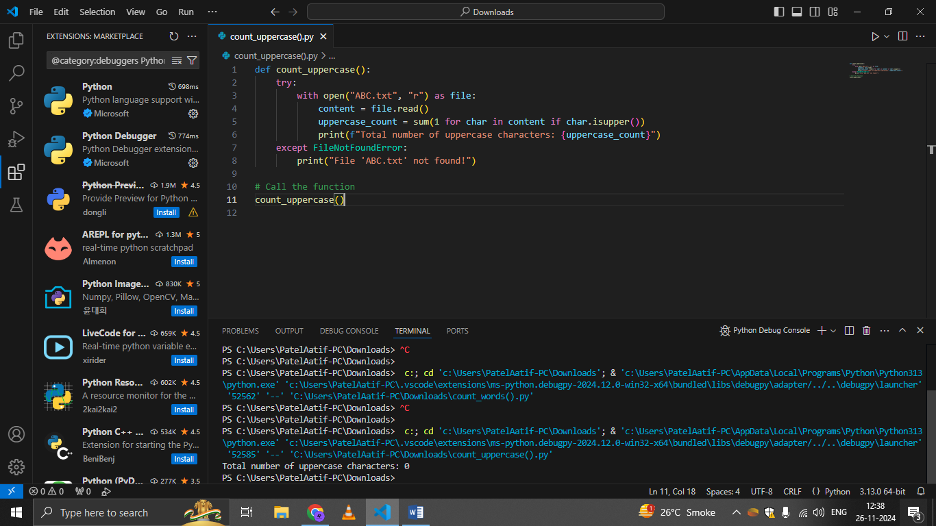

4. Write a function display_words() in python to read lines from a text file "story.txt", and display those words, which are less than 4 characters.

def display_words():

    try:

        with open("story.txt", "r") as file:

            for line in file:

                words = line.split()

                short_words = [word for word in words if len(word) < 4]

                if short_words:

                    print("Words with less than 4 characters:", " ".join(short_words))

    except FileNotFoundError:

        print("File 'story.txt' not found!")

# Call the function

display_words()

OUTPUT

